NMD 345/ Spring
Reading Response #1/ Professor Ippolito
Tuesday, January 21, 2014

-Answers to: Ken Jacob’s Digital Decay-

1.) Something essential to life, bad for our artifacts: Sunlight, water, fire, food.
2.) Demagnetize: Tape demagnetizes, breaks down; just as CD delaminate.
Tape is made up of bits, bits are magnetized clumps of atoms, images burned into plastic, iron filings stuck together with tape. “Bits have no archival medium.” (Jacobs, pg 20).
3.) Entropy: We can’t fix our own technology, we don ‘t know how; computers are being made by computers.
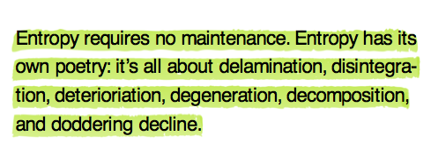
4.) Are bits more durable than atoms?
From what I read, Jacobs is saying atoms are more reliable than bits. If video tape is a bit, and atoms are essentially conducting everything we use on a computer, then I believe his argument was strongly leaning on the latter. Jacobs points out, that with sharing via copies, e-mail, external hard-drives it is becoming much more efficient to store data; but counter-argues that a new generation will take over and who knows what bits they will use.
*Jacob’s describes atoms as immaterial.
5.) Computer Processing Speed; It’s doubling every 18 months.
6.) What is the Blue Screen of Death?
Tapes demagnetize, CDs delaminate and software crashes.
